Lesson 1 of 6
Introduction

Integrity and value for money go hand-in-hand – by definition, corruption represents a failure to achieve value for money
Lewis Rangott - Executive Director Corruption Prevention, ICAC NSW
What impacts do you think the perception of corruption in NSW Government can have on procurement?
- Perceptions of corruption may deter quality suppliers from making offers, reducing competition
- Perceptions of corruption may attract disreputable, poor performing or corrupt suppliers
- Less competition leads to weaker markets and higher prices
- Suppliers are members of the public and public confidence needs to be maintained
- If suppliers believe the process is corrupt they may be inclined to act corruptly themselves
SUBMIT
Impacts of corrupt conduct by a public official
Impact | Example
Direct financial loss | Paying too much, paying twice because goods or services weren’t supplied the first time
Wasted resources | Public resources used to overpay a supplier or taken by a public official
Reduced operational effectiveness | Poorly performed maintenance services result in service disruptions
Lowered morale | Staff discouraged or distressed by corrupt colleague’s corruption
Reputational damage | Reputational damage to the agency and individual staff – this can make it hard to retain or attract good staff or suppliers
Erosion of public trust | Loss of faith in the integrity of the agency – this can lead to a loss of ministerial confidence and a public unwilling to constructively engage with the agency
Lesson 2 of 6
What is corruption?

Corrupt conduct is deliberate or intentional wrongdoing, not negligence or a mistake. It has to involve or affect a New South Wales public official or public sector organisation.
Independent Commission Against Corruption (ICAC)(opens in a new tab)
Corrupt conduct occurs when...
Public officials
Corrupt conduct occurs when a public official:
- improperly uses, or tries to improperly use, the knowledge, power or resources of their position for personal gain or the advantage of others
- dishonestly or improperly exercises their official functions:
  - in a partial manner
  - in a way that breaches public trust
- misuses information or material acquired during the course of their official functions.

Members of the public
Corrupt conduct occurs when a member of the public influences, or tries to influence, a public official to use their position in a way that is dishonest or partial.
Any person
Corrupt conduct occurs when the actions of any person impairs, or could impair, public confidence in public administration. This could involve:
- collusive tendering
- fraud in relation to applications for licences, permits or other authorities
- dishonestly obtaining, assisting in obtaining, or dishonestly benefiting from, public funds or assets for private advantage
- defrauding the public revenue
- fraudulently obtaining or retaining a position as a public official.
Conduct is only corrupt if it could constitute or involve:
- a criminal offence
- a disciplinary offence
- reasonable grounds for dismissal
- substantial breach of an applicable code of conduct (for Ministers and MPs).
- Examples of corrupt conduct in procurement
- Example 1
- Sharing confidential information
A public official providing confidential information to a supplier or tenderer to intentionally give an unfair advantage. Example 2
Private interests
A public official involved in procurement secretly owning a private company, submitting bids and influencing the assessment to advantage their own company.
Example 3
Falsifying invoices
A public official colluding with a contractor to falsify or inflate invoices.
Example 4
Over-ordering
Deliberately over-ordering goods and keeping the extra for private use.
Example 5
Suppliers colluding
Two suppliers colluding amongst themselves to artificially elevate prices or manipulate which of them wins the work. Procurement outcomes resulting from corrupt conduct
Corruption in procurement can be difficult to detect because it often involves a secret arrangement that two or more corrupt parties are happy with. However, you can better detect and prevent corruption if you understand and manage unwanted procurement outcomes.
While the following negative outcomes could be due to poor systems and practices, they can also be a result of corrupt conduct:
Overcharging
Corruption usually involves the improper transfer of something valuable from public to private hands. One of the most direct ways this can happen in procurement is by intentional overcharging. For example:
- approving unnecessary or over-priced contract variations
- accepting unreasonably high bids and paying an excessive price
- paying invoices that are improperly charged at above contract rates.
Underdeliver
Underdelivery is about receiving less than what was expected and paid for. Examples include:
- paying invoices where no items are delivered
- receiving lesser quality goods or services than specified, for example less thorough advice or poorer service
- receiving a lesser quantity of goods or services than specified, for example fewer computers or less regular cleaning services.
Overservicing
Overservicing includes ordering and paying for items that are surplus to agency needs or are of a higher quality or specification than required, even if the correct price is paid for the higher quality goods or services.
Incorrect supplier choice
Incorrect supplier choice results in a supplier being awarded work undeservedly. There are several ways this can happen corruptly, including:
- confidential information being leaked to a supplier to give them an advantage
- assessment criteria being weighted to favour a supplier’s bid
- suppliers lying about their capability or credentials in order to make them appear more desirable than other suppliers.
Lesson 3 of 6
Corruption risks in procurement

Common corruption risks in procurement include:
- abuse of a conflict of interest
- misuse of information
- improper influence
- individuals with high levels of discretion, autonomy, power or influence over the procurement process.
Abuse of a conflict of interest
Conflicts of interest can lead to corrupt conduct. Even honest public officials may be unintentionally biased by their relationships and interests.
A conflict of interest exists when a reasonable person might perceive that a public official’s personal interests could be favoured over their public duties.
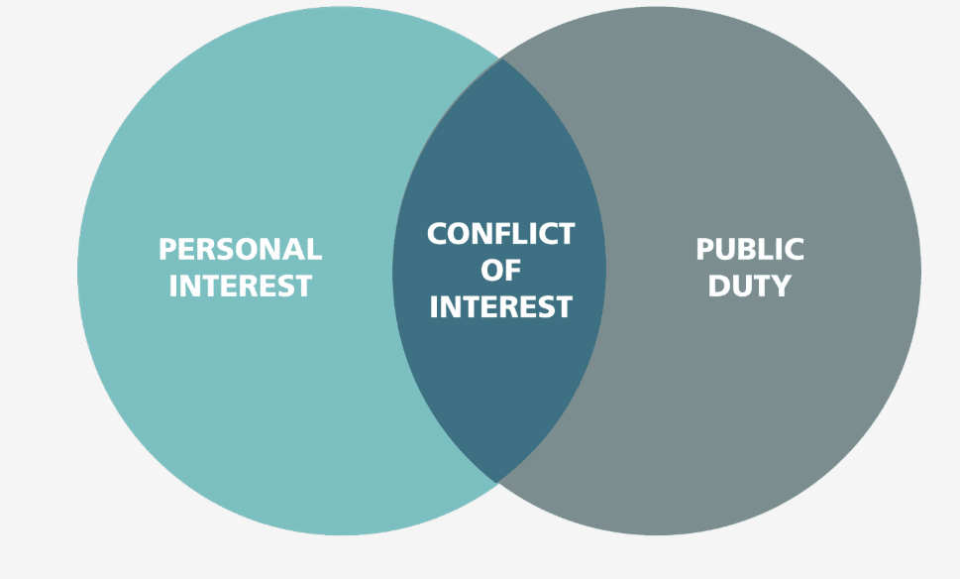 Personal interests include:

- family and friends
- career opportunities
- financial interests
- power and influence.
Public duty includes:

- performing your duties
- complying with policies and procedures
- serving the public interest, your agency and the public in an ethical manner.
Personal interests that may trigger a conflict of interest
Pecuniary interests
Pecuniary interests involve an actual or potential financial gain or loss. For example, a public official, their family, friend or associates gain benefit financially.

Examples include:
- sources of income, including secondary employment
- ownership or lease of land, buildings and property
- shares or investments in companies, partnerships or other entities
- an option to buy or sell an asset.
People who are more than acquaintances
Any relationship with a person, who is more than an acquaintance, could amount to a personal interest. You should carefully consider how a reasonable person might view your personal relationship.

Examples include:
- spouses
- relatives (including by marriage and close family friends)
- friends
- current romantic partners
- close colleagues and mentors
- social connections.
Feelings of animosity towards a person can also constitute a personal interest.
People providing income
Connections to people who have provided or may provide income are likely to be personal interests.

Examples include:
- providers of secondary or other employment
- current or former business partners
- customers, significant suppliers or contractors of a private business or secondary employer
- future employment or business opportunity (to the official or family member)
- relationships with former employers and colleagues, especially if there is ongoing social contact.

Organisations and clubs, and people connected to them
A personal interest may arise from a connection with organisations or clubs, including professional, sporting, recreational, community, arts or social organisations.

Hobbies that you're passionate about could a
People and entities who give benefits or favours
Officials may have a personal interest if they could feel (or are perceived to be) indebted or obligated to anyone who has provided gifts, benefits, hospitality or favours.

A potential sense of obligation can arise from:

- gifts, benefits or hospitality that are more than token in nature
- favours or valuable advice
- discounts on the provision of goods and services
- borrowing equipment or other items
- sponsorships or donations to causes associated with a public official.

Close connections to the public official
Other people or matters that are closely connected to the public official might also give rise to a personal interest. This could include social media associations.

You should always be prudent about the way they use social media. You should generally avoid endorsing products, services or companies connected to your work.
Consider these four elements when determining if a conflict of interest exists:
- 1
Does the official have a personal interest?
- 2
Does the official have a public duty?
- 3
Is there a connection between the personal interest and the public duty?
- 4
Could a reasonable person perceive that the personal interest might be favoured?
Conflicts of interest are not wrong in themselves. It's how you manage them that is important. To protect yourself and your agency, you must disclose all conflicts of interest and follow your agency’s conflicts of interest management policy.
To learn more about conflicts of interest, refer to the NSW ICAC’s FAQs for public officials(opens in a new tab) and Managing conflicts of interest in the public sector(opens in a new tab) publication.
Misuse of information
Procurement processes generate a range of documents and information that may be misused to gain an unfair advantage. These can originate from buyers or suppliers.

Examples of misusing information include:
- using confidential information to help a supplier prepare bids
- giving one supplier's prices to another, enabling them to meet or beat the first supplier's price
- sharing information gained during negotiations with one supplier to help another supplier.
Buyer information
Buyer documents and information include:
- evaluation criteria
- project budget/contingency
- evaluation panel members
- EOI responses.
The improper or untimely release of this information may give a favoured supplier an unfair advantage.
Supplier information
Supplier documents and information include intellectual property commercial-in-confidence information.
Improper sharing of this information with a competitor may result in the competitor getting an unfair advantage and the supplier being disadvantaged in the broader market as well.
You must maintain confidentiality and follow your agency's policies and processes for record keeping and information security.
You're part of an evaluation team procuring a new cloud-based learning platform.
One of the suppliers has contacted you to ask which other solutions you're looking at and which suppliers have been invited to respond to request for quote.

What should you do?
- Decline to provide the information as this is confidential
- Provide this information as it will help the supplier to provide a fit for purpose response
- Record details of what happened and report it
- Follow my agency’s policies and procedures

Suppliers may attempt to obtain information they are not entitled to.

You must know what information you can and can’t share and be aware of suppliers trying to trick you into providing information or otherwise gain favourable treatment.
Improper influence
Suppliers improperly influencing public officials
Suppliers may attempt to improperly influence public officials to perform actions that advantage them by offering immediate or future benefits. This can involve:
- enrichment, such as gifts and benefits
- relationships, such as the cultivation of a friendship
- coercion, for example by blackmail.
Examples include:
- the offer of a bribe to influence a current procurement process
- ‘grooming’ via a series of gifts to obtain favourable treatment in future contract management processes.

You manage the contract for analytics software that your team uses. The contract is due to expire and you plan to run a competitive tender process to consider both new and existing products on the market.

Over the years, you've developed a good working relationship with the supplier for the existing contract and you both share a passion for dachshund dogs. In a telephone call, the supplier suggests going to a dachshund meet-up at the park together.
What should you do?
- Accept the invitation - I can keep my work and private life separate and resist any attempts to influence me
Correctly unchecked
- Decline the invitation
Correctly checked
- Report any attempt made by the supplier to improperly influence me
Correctly checked
- Implement an appropriate management strategy with my manager

Correctly checked
- Declare all perceived, potential and actual conflicts of interest as per my agency’s policies and procedures

It's easy to develop friendly relationships with suppliers or contractors. However, friendships can lead to biased decision making.

You must be aware of suppliers trying to develop friendships to gain influence and follow your agency's policies and procedures for managing conflicts of interest.
Gifts and benefits
Gifts and benefits are often used by suppliers to ingratiate themselves with buyers. Suppliers may also use gifts to create a sense of friendship with buyers and of being indebted. This can result in a buyer placing unwarranted trust in a supplier and unwittingly being influenced by them. Gifts are also used to incentivise and reward collusive corrupt conduct.
If you are offered gifts or benefits, think about the intent of the offer and the potential impact on you. Ask yourself:
You must follow your agency’s gifts and benefits policy. The safest and easiest option is to decline and declare all gifts or benefits.

Declaration is important because it helps your agency work out if particular suppliers are systematically targeting people in your organisation.
Supplier due diligence
In a nutshell, due diligence helps to answer the question:
"Should we be doing business with this supplier?"
Numerous ICAC investigations have shown that poor due diligence has led to corrupt conduct.
Conducting supplier due diligence helps you to ensure value for money, prevent corrupt conduct, maintain trust in public administration and comply with legal and regulatory expectations.
Ensuring that suppliers are legitimate and capable of delivering the goods or services specified in your contract is your responsibility.
Check the Independent Commission Against Corruption's (ICAC) Supplier Due Diligence guide(opens in a new tab) for more information, including guidance on the specific checks you can make.
Lesson 4 of 6
Your obligations to act ethically and in the public interest
NSW Government's ethical framework
The Government Sector Employment (GSE) Act 2013(opens in a new tab) sets the legal requirements for all people employed in the public sector to act ethically and in the public interest. You must:
- •
comply with the law and ethical obligations
- •
follow your agency’s policies and procedures
- •
be professional and uphold the probity principles
- •
be impartial and treat suppliers fairly and consistently
- •
effectively manage conflicts of interest and offers of gifts and benefits
- •
be accountable for your decisions and actions.
Refer to the NSW Public Service Commission’s Behaving Ethically: A guide for NSW government sector employees(opens in a new tab) to better understand your obligation to act ethically.
Report corrupt conduct

Reporting actual or suspected corruption:
- helps to ensure the highest ethical standards are maintained in the NSW public sector
- reduces the effects of corruption by allowing it to be dealt with promptly and effectively
- helps prevent future corruption because of the likelihood that such conduct will be reported
- is in the public interest.
You do not have to prove that a matter is serious before you report it. All suspicions of corruption on reasonable grounds should be reported as soon as possible.
How to report corrupt conduct
You can report suspected corrupt conduct:
- directly to the agency concerned
- internally using your agency’s internal reporting process
- directly to the NSW ICAC(opens in a new tab).
Under the Public Interest Disclosures (PID) Act, there are protections for NSW public officials reporting corrupt conduct. You can make a PID internally or to the ICAC, but you must make sure you comply with the PID Act to secure the associated PID protections.
For more information on how to make a PID, consult your agency’s Public Interest Disclosures policy or contact the NSW Ombudsman PID Unit(opens in a new tab).
Lesson 6 of 6
Summary
Key Takeaways
As a public official, you're obligated to act ethically and to help prevent corruption. Remember, you're accountable for your decisions and actions.
- 1
Corrupt conduct is deliberate or intentional wrongdoing, not unintentional negligence or a mistake.
- 2
Understanding and managing unwanted procurement outcomes, such as overcharging, underdelivering, overservicing and incorrect supplier choice, can help you to prevent corruption.
- 3
It's important to know what information you can and can’t share. Maintaining confidentiality will help you to ensure that information is not misused.
- 4
Be aware of suppliers trying to develop friendships to gain influence.
- 5
To protect yourself and your agency, you must disclose all conflicts of interest. It's also safest and easiest to decline and declare all gifts or benefits.
- 6
Always follow your agency's policies and procedures.
- 7
Report suspected corruption to the organisation concerned, internally using your agency's reporting process, or directly to the ICAC. To benefit from the protections provided under the Public Interest Disclosure Act (PID Act), ensure that your report satisfies the PID reporting requirements.

